**How to host a Vortex Quake 2 server & create nav files for bots**

Prerequisites

* Vortex [client](https://q2vortex.com/q2vortex.zip) files
* Vortex [asset](https://github.com/VortexQuake2/VortexAssets) files (you may already have these from playing)
* Vortex server files from [GitHub](https://github.com/VortexQuake2/Vortex/tree/master/server)
  + Note: The easiest way to download a folder from GitHub is to use [download-directory](https://download-directory.github.io/?url=https%3A%2F%2Fgithub.com%2FVortexQuake2%2FVortex%2Ftree%2Fmaster%2Fserver)
* Vortex shared library files for Windows (.dll) or Linux (.so)

Steps

1. Extract the server files you downloaded from GitHub to your /Quake2/vortex folder
2. Windows: Create a batch file or shortcut with the following parameters:

**q2proded.exe +set dedicated 1 +set game vortex +exec server.cfg +set port 27910 +map q2dm1**

1. Launch your dedicated server and join the game with a separate client (ideally windowed so that you can still read and interact with the server console)
2. In the server console, switch to a map that you haven’t made any bot nav files for. You should see this message in the console:



1. In the server console, type ‘sv aidebug’ and ‘sv makenodes’

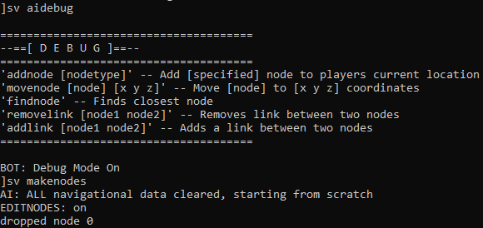

1. Walk around the map, exploring all areas, ladders, doors, jumps, water areas, and teleporters. You’ll know you’re done when you no longer see ‘dropped node’ messages (and the accompanying sounds/effects) in the console.
2. In the server console type ‘sv savenodes’ to save the nodes you’ve created to a .nav file in /vortex/settings/navi

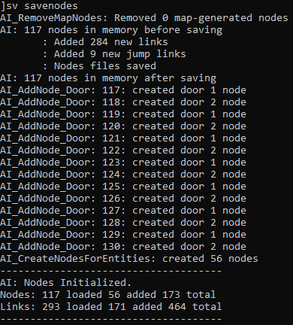

1. In the player (client) console, type ‘showplinks’ to show the nodes and the links between them (called plinks, short for player links)

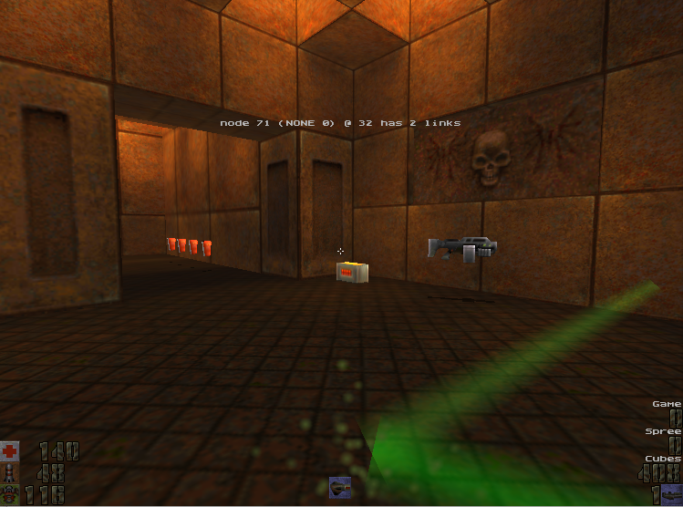

1. In the screenshot above, the particle effects denote the location of nodes, and the green lasers show the links between various nodes. The centered white text tells you the node number, the type of link, the distance from the closest node, and the number of links from that node to other nodes. Note that there is no link going to the armor shards and the ramp to the left. As you walk around examining the nodes and links, look for gaps of missing links, no links, or too many. Missing links will need to be filled in by adding nearby nodes, and nodes with too many links or badly positioned, may need to be deleted.
2. At the player/client console, type ‘bind j aiaddnoe’ and ‘bind k airemovenode’. Change the keys to anything convenient. Use the former to add a node, and the latter to remove one.
3. When you are done manually adding and removing nodes, at the server console, type ‘sv savenodes’ to save your progress, then type ‘bot_dropnodes 0’ to stop dropping nodes.
4. To verify that the nodes are good, you can add bots to your game with the ‘sv addbot’ server command. Observe how they navigate around the map and look for issues, e.g. getting stuck, not being able to reach items, etc.
5. There are some known issues working with nodes and AI limitations. Report any observations to the devs in the Vortex Discord channel.
6. If you want to continue to make nodes for additional maps, go to step 4. You won’t have to type ‘sv aidebug’ again.

Thanks for your help!